**Assignment – 15**

Name- Yashraj Ranjeet Shitole

Roll no. - 86633

1) Assume there is a table called Multicust, with all of the same column definitions as Salespeople. Write a command that inserts all salespeople with more than one customer into this table.

**Create table Multicust as select * from salespeople where snum in (select snum from customers group by snum having count(snum)>1 );**

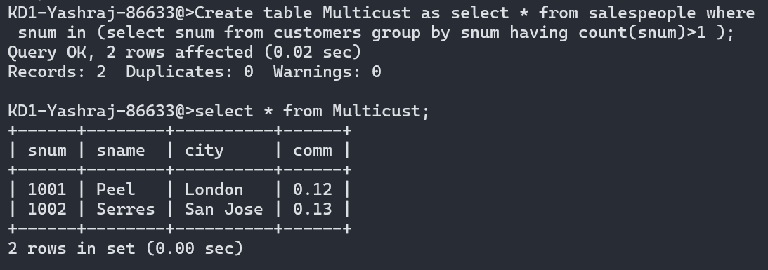

2) Write a command that deletes all customers with no current orders.

**Delete from customers where cnum not in (select cnum from orders);**

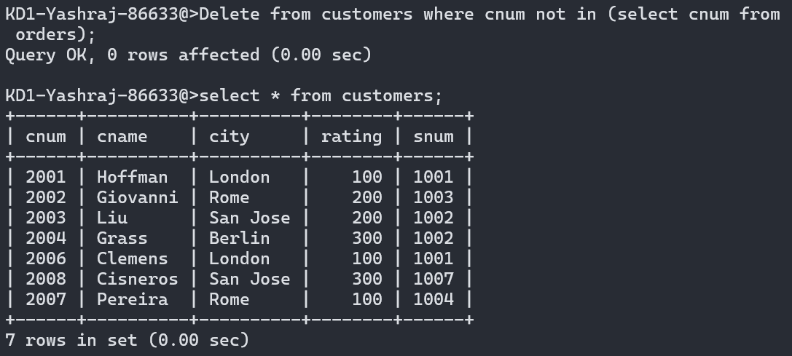

3) Write a command that increases by twenty percent the commissions of all salespeople with total orders above Rs. 3,000.

Update salespeople set comm=comm+0.2 where snum=(select snum from orders where amt>3000);

